**Medicine Analysis Report**

* Prepared by: Yogeshwari Harne
* Guide by: Vishal sir

**Introduction:**

This dataset contains detailed information on 112,17medicines, including their price, manufacturer, composition, and whether they are discontinued. Key columns include the medicine name, price in INR, manufacturer name, and pack size. It can be used for price analysis, market trends, and discontinuation patterns, providing valuable insights into the pharmaceutical industry.

**Objective:**

* Identify the top 5 most frequently used Short Composition1 and Short Composition2.
* Highlight the manufacturers associated with these top compositions.
* Provide actionable insights for decision-makers regarding the distribution of these compositions and potential strategies for optimizing production and cost

**Data Overview:**

### ****Data Source:****

### *The dataset is sourced from and Medicine analysis .It is publicly available on Kaggle platform.*

### Data Description:

* **Short Composition1:** The primary composition of the product.
* **Short Composition2**: The secondary composition of the product.
* **Manufacturer**: The company producing the product.
* **Price**: The cost of the product in Indian Rupees (₹).
* **Records**: [Number of rows - 11217]
* **Features**: [Number of columns -10]

**Methodology:**

* The analysis was conducted using Python and key libraries such as Pandas for data manipulation, Seaborn and Matplotlib for data visualization, and Microsoft Word for report preparation. Statistical methods including mean, median, mode, and the five-number summary .

* **Medicines by price category:**

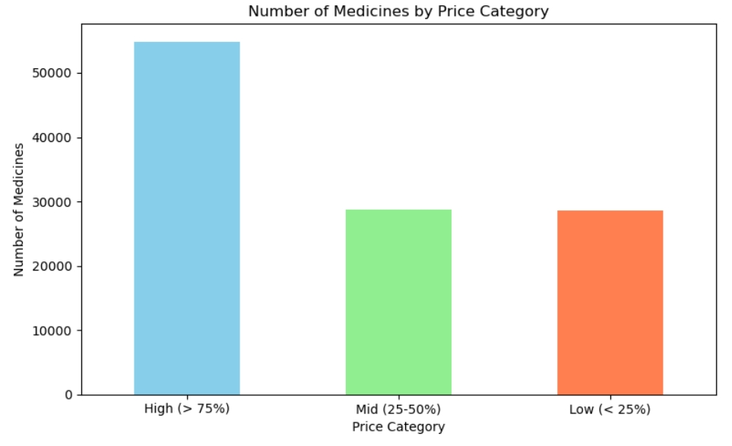

**Key findings:**

min 1.25000   
25% 55.00000   
50% 85.00000   
75% 140.00000   
max 119500.00000

* **High-priced medicines :** (above ₹140) dominate the dataset, with over 50,000 medicines.
* **Mid-priced medicines :** (₹55 to ₹85) and
* **low-priced medicines** : (below ₹55) are almost equal in number, each with roughly around 20,000–25,000 medicines
* **Manufacturers with most medicines:**

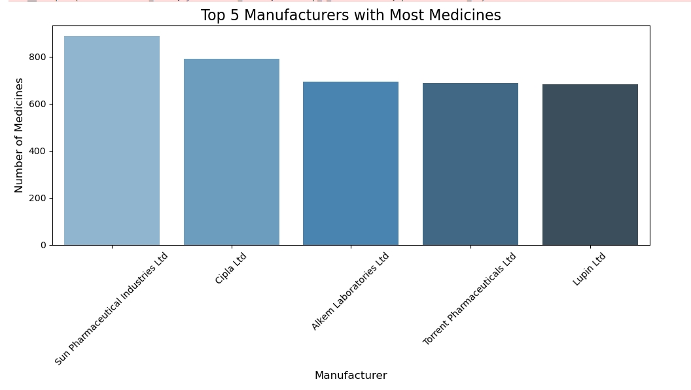

**Key finding:**

* Sun Pharmaceutical Industries Ltd is the leading manufacturer, producing the highest number of medicines, just over 800.
* Cipla Ltd follows closely, with around 800 medicines.
* Alkem Laboratories Ltd,

Torrent Pharmaceuticals Ltd, and Lupin Ltd have similar counts, all in the range of 600 to 700 medicines

* **Top 5 Price Manufactures:**

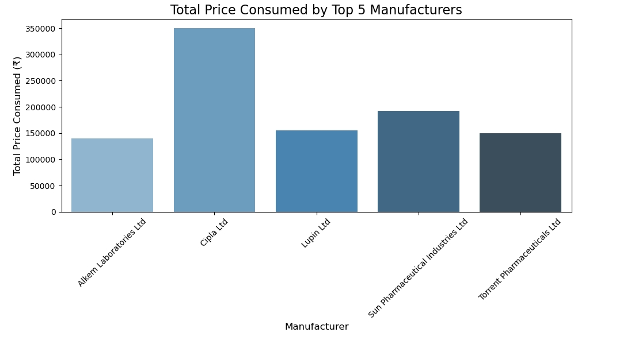

**key finding:**

manufacturer_ name price(₹)

0 Alkem Laboratories Ltd 140432.21

1 Cipla Ltd 349827.96

2 Lupin Ltd 155236.99

3 Sun Pharmaceutical Industries Ltd 191965.13

4 Torrent Pharmaceuticals Ltd 150113.75

* **Bottom 5 Price Manufactures**

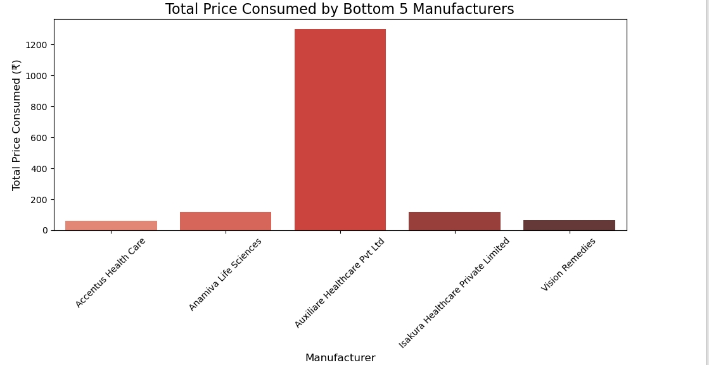

**Key finding:**

Manufacturer _name price(₹)

0Accentus Health Care 60.0

1 Anamiva Life Sciences 120.0

2Auxiliare Healthcare Pvt Ltd 1299.0

3Isakura Healthcare Private Limited 120.0

4 Vision Remedies 64.0

* Auxiliare Healthcare Pvt Ltd has the highest expenditure among the bottom 5 manufacturers, significantly higher than the others, with a total price consumed of over ₹1200.
* The other four manufacturers (Accentus, Anamiva, Isakura, and Vision Remedies) show much lower expenditures, all well below ₹250.
* Accentus Health Care and Vision Remedies have the lowest expenditures, nearly equal and quite minimal in comparison to Auxiliare Healthcare Pvt Ltd.
* There is a wide disparity between Auxiliare and the rest of the manufacturers, with Auxiliare dominating the costs in this group.
* Medicines: There are very few medicines in the "High Price" category (above ₹2000). These are likely niche, premium, or highly specialized medications
* **Pack Sizes:**

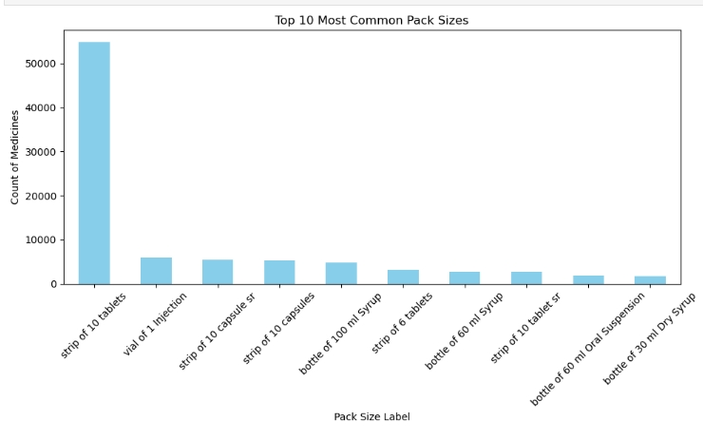

**Key finding:**

* **Strip of 10 tablets** is overwhelmingly the most common pack size, with over 50,000 occurrences. This indicates that a large portion of medicines in the dataset are packaged in strips containing 10 tablets.
* Other common pack sizes include **vials for injection** and **strips of capsules** (both regular and slow-release), though these have significantly fewer occurrences compared to "strip of 10 tablets.“
* Liquid formulations like **syrups** are also common, with pack sizes such as **60 ml** and **100 ml bottles** appearing in the top 10.
* **'Top 5 Most Used Short Composition1**

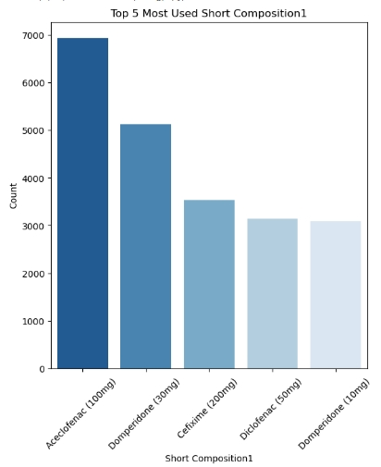

**Key finding:**

• **Aceclofenac (100mg)**: Most commonly used, with nearly 7,000 instances.

• **Domperidone (30mg)**: Second most used, around 5,000 instances.

• **Cefixime (200mg)**: Around 3,500 instances.

• **Diclofenac (50mg)** and **Domperidone (10mg)**: Both used approximately 3,000 times each..

* **'Top 5 Most Used Short Composition2**

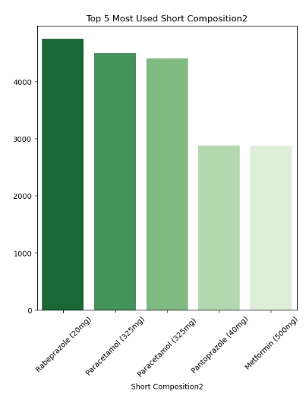

**Key finding:**

• **Rabeprazole (20mg)**: Most commonly used in this category, with about 4,500 instances.

• **Paracetamol (325mg)** and **Paracetamol (325mg)**: Both close to 4,000 instances.

• **Pantoprazole (40mg)** and **Metformin (500mg)**: Used around 3,000 times

* **Aceclofenac (100mg)** in Short Composition1 and **Rabeprazole (20mg)** in Short Composition2 are the most frequently used compositions in their respective categories.
* Domperidone and Paracetamol appear more than once with different dosages, indicating their wide usage across different strengths.
* **CONCLUSION:**
* **Price Distribution**: The majority of medicines fall within the higher price range (above ₹140), indicating thatpremium-priced products dominate the dataset.
* **Manufacturers**: Leading pharmaceutical companies like **Sun Pharma** and **Cipla** are major contributors, producing the highest number of medicines.
* **Discontinued Medicines**: There's a relatively small difference in price between discontinued and non-discontinued medicines, suggesting price may not be the sole factor in discontinuation decisions.
* **RECOMMENDATION:**
* **Introduce affordable options** to cater to price-sensitive customers.
* **Analyze product discontinuation** to prevent with market leaders.
* **Smaller manufacturers** can focus on niche areas to compete with market leaders.
* **Expand mid and low-price products** to tap into underserved segments.